ECA 1011 – MICROPROCESSOR AND MICROCONTROLLERS
Name : HARIHARAN.R
Reg No : 192524003
Experiment 02: Analysis, Development, and Verification of Logical, Bit Manipulation, and Shift Operations Using Assembly Language
Objectives
- To analyze and verify 8-bit and 16-bit Logical operations (AND, OR, XOR) using an 8-bit microprocessor.
- To analyze and verify Bit Manipulation operations (Setting, Clearing, and Complementing specific bits).
- To analyze and verify Shift and Rotation operations (Logical/Arithmetic shifts left and right) using 8-bit data.
Components Required
- 8085 Simulator Software
Procedure
- Launch the 8085 Simulator application on your system.
- Type or paste the respective Assembly Language Program (ALP) into the editor/assembler window.
- Assemble/Compile the code to convert the assembly mnemonics into machine hex code. ensure zero syntax errors.
- Open the Memory Editor and manually input your test operands into the designated starting memory addresses.
- Execute the program using the Run or Step-by-Step (Trace) feature to observe how registers and condition flags alter.
- Verify your outputs by checking the target memory locations and register statuses against your theoretical manual calculations.

  - To analyze and verify 8-bit and 16-bit Logical operations (AND, OR, XOR) using an 8-bit microprocessor.
Code:
AND(8 bit):
LDA 4600
MOV B, A
LDA 4601
ANA B
STA 4602
HLT
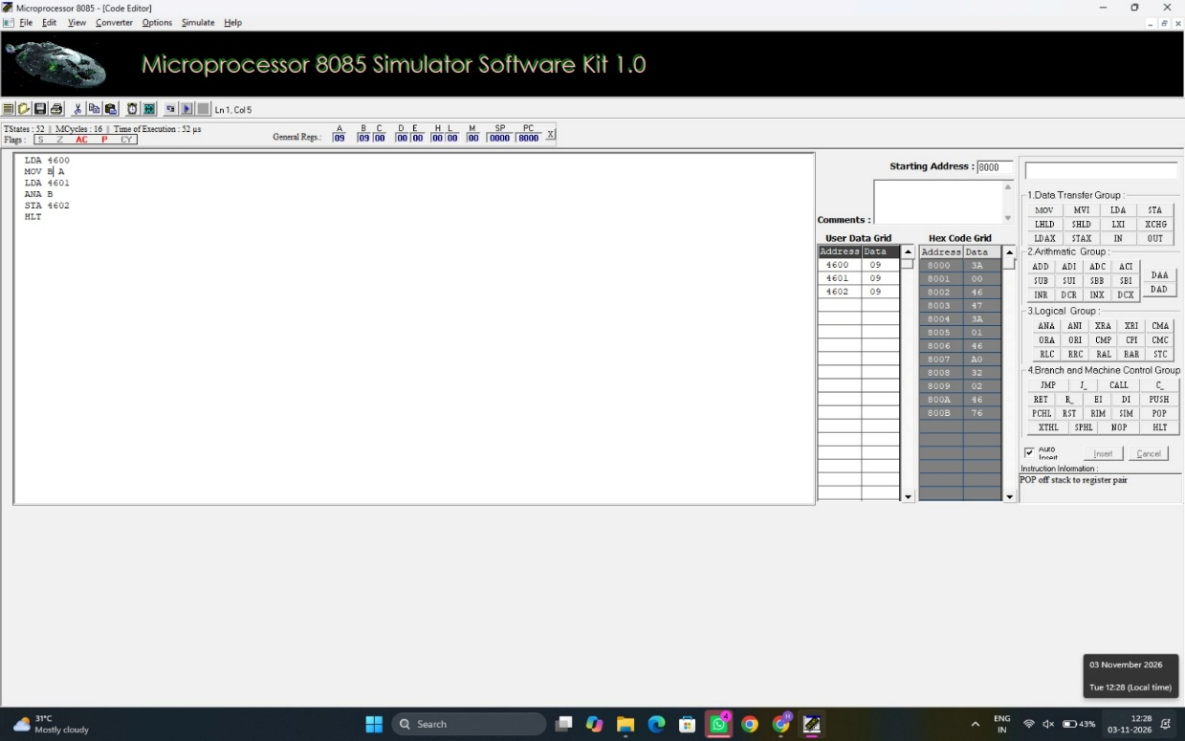
Data Table:
4600 | 09
4601 | 09
4602 | 09

Code:
OR(8 bit):
LDA 4600
MOV B, A
LDA 4601
ORA B
STA 4602
HLT
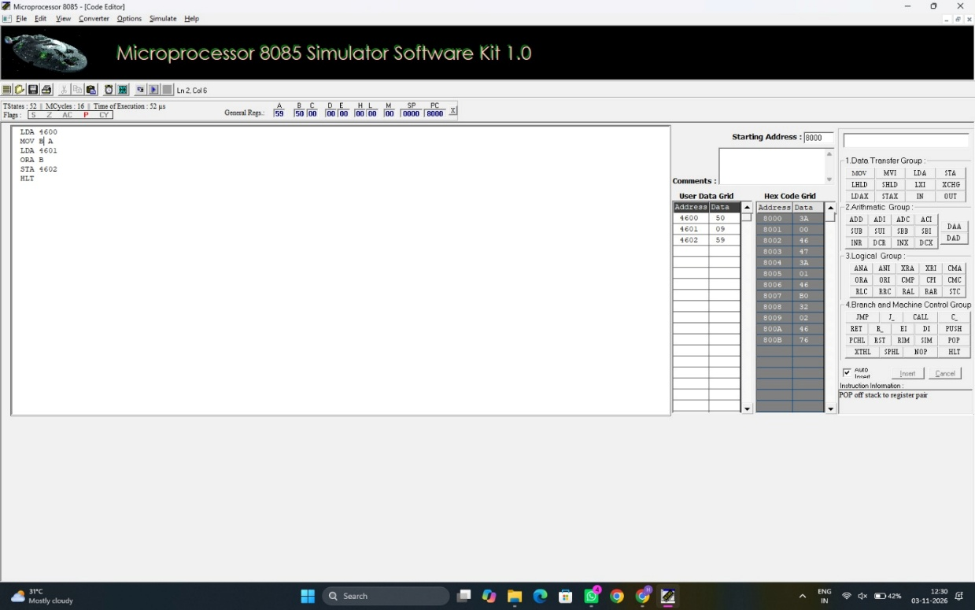

Data Table:
4000 | 59
4001 | 09
4002 | 59

Code:
XOR(8 bit):
LDA 4600
MOV B, A
LDA 4601
XRA B
STA 4602
HLT
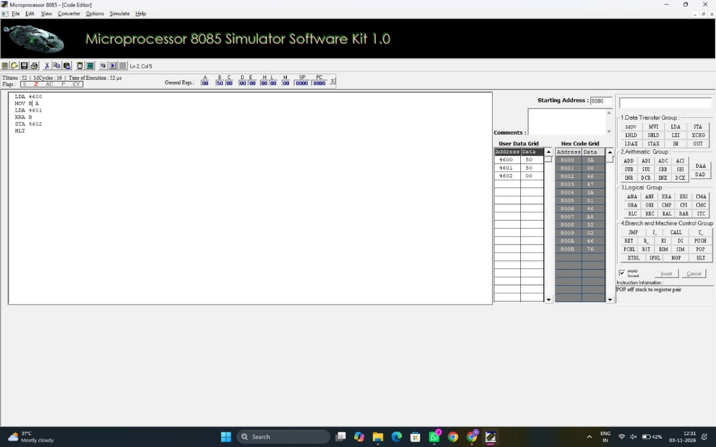
Data Table:
4600 | 50
4601 | 50
4602 | 00

Code:
AND(16 bit):
LHLD 4600
XCHG
LHLD 4602
MOV A, E
ANA L
MOV E, A
MOV A, D
ANA H
MOV D, A
XCHG
SHLD 4604
HLT
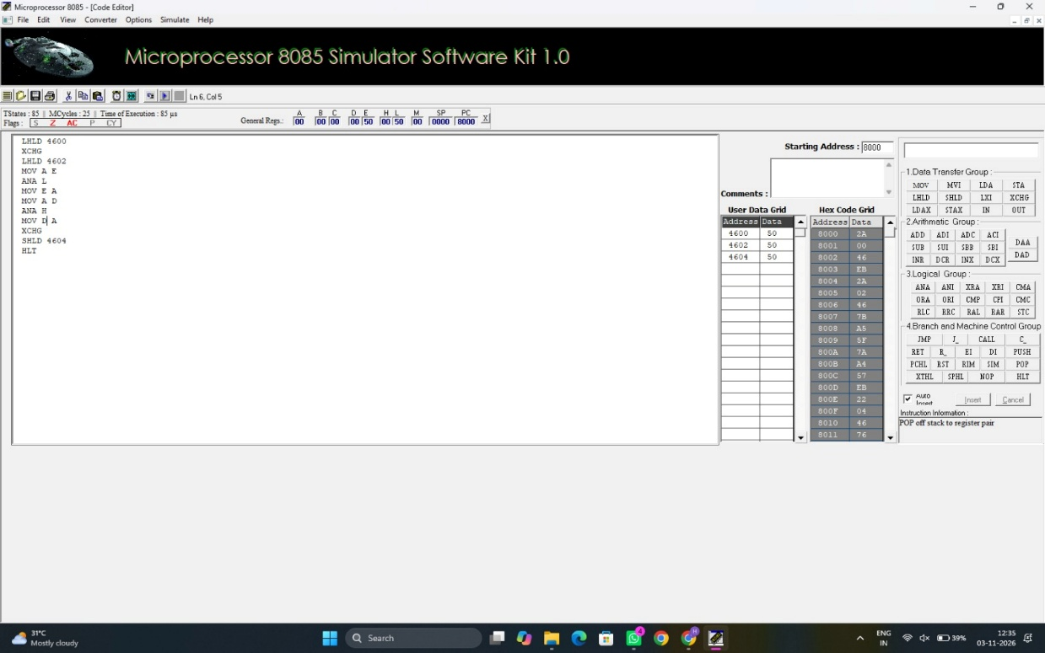
Data Table:
4600 | D5
4601 | F8
4602 | CD
4603 | D5
4604 | 08
4605 | 23
Code:
OR(16 bit):
LHLD 4600
XCHG
LHLD 4602
MOV A, E
ORA L
MOV E, A
MOV A, D
ORA H
MOV D, A
XCHG
SHLD 4604
HLT
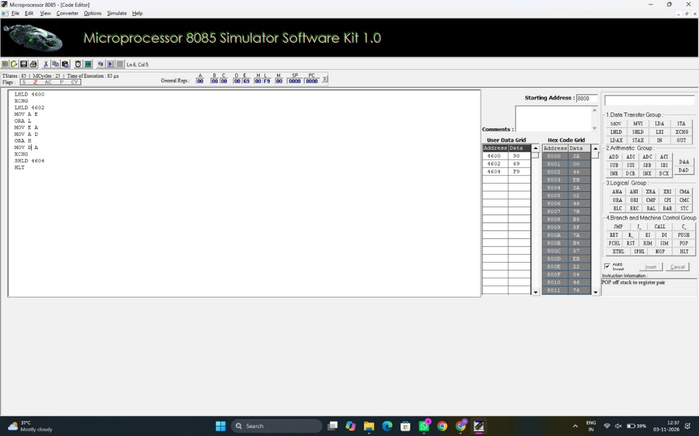

Data Table:
4600 | D5
4601 | F8
4602 | CD
4603 | D5
4604 | 08
4605 | 23

Code:
XOR(16 bit):
LHLD 4600
XCHG
LHLD 4602
MOV A, E
XRA L
MOV E, A
MOV A, D
XRA H
MOV D, A
XCHG
SHLD 4604
HLT
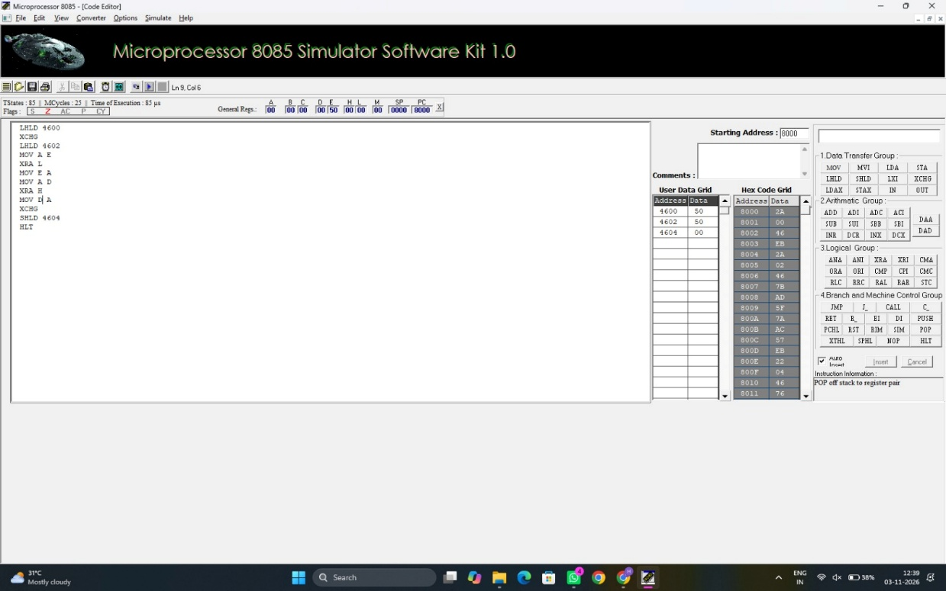

Data Table:
4600 | D5
4601 | F8
4602 | CD
4603 | D5
4604 | 08
4605 | 23

  - To analyze and verify Bit Manipulation operations (Masking and Biting).

Code:
MASK(8 bit):
LDA 4600
MOV B, A
LDA 4601
ANA B
STA 4602
HLT
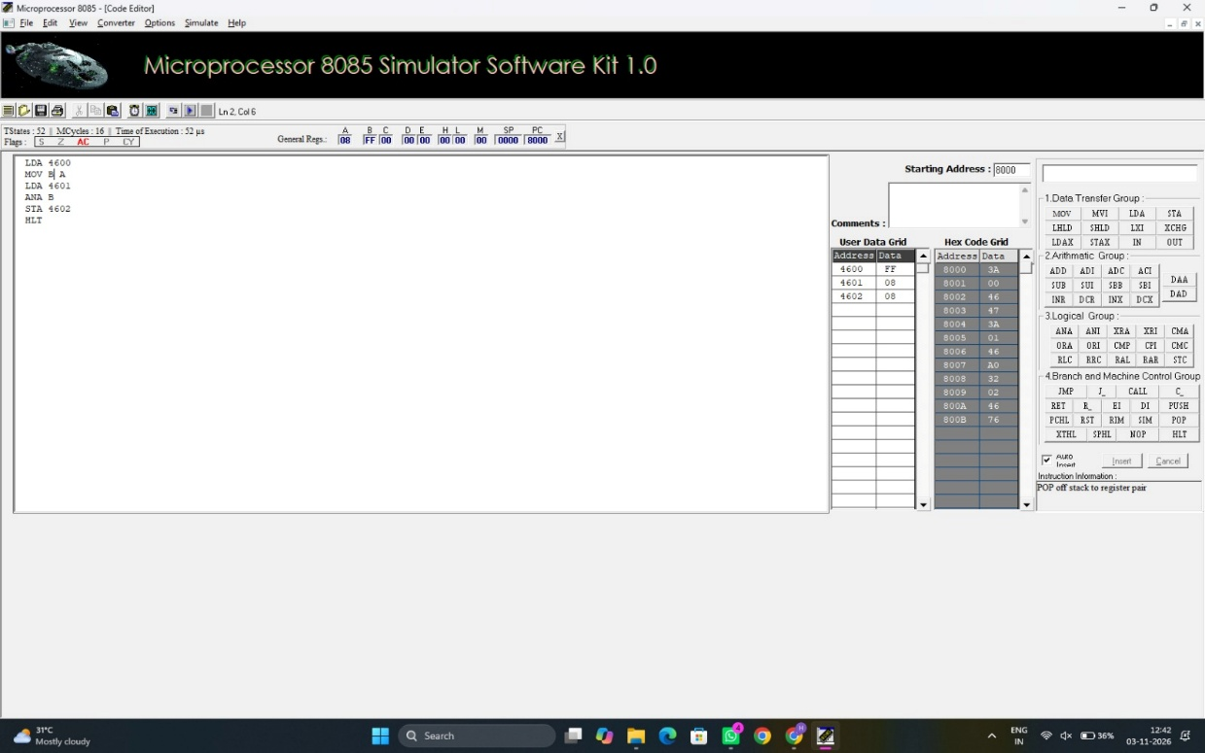
Data Table:
4600 | 00
4601 | 20
4602 | 20

Code:
BIT(8 bit):
LDA 4600
MOV B, A
LDA 4601
ANA B
STA 4602
HLT
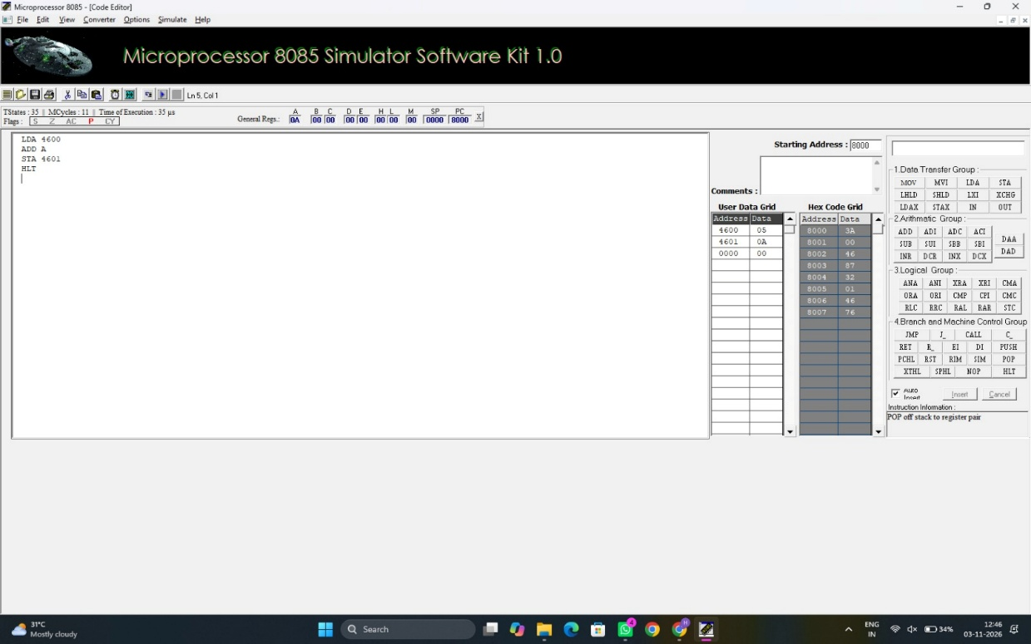
Data Table:
4600 | 20
4601 | 00
4602 | 00

Code:
MASK(16 bit):
LHLD 4600
XCHG
LHLD 4602
MOV A, E
ANA L
MOV E, A
MOV A, D
ANA H
MOV D, A
XCHG
SHLD 4604
HLT
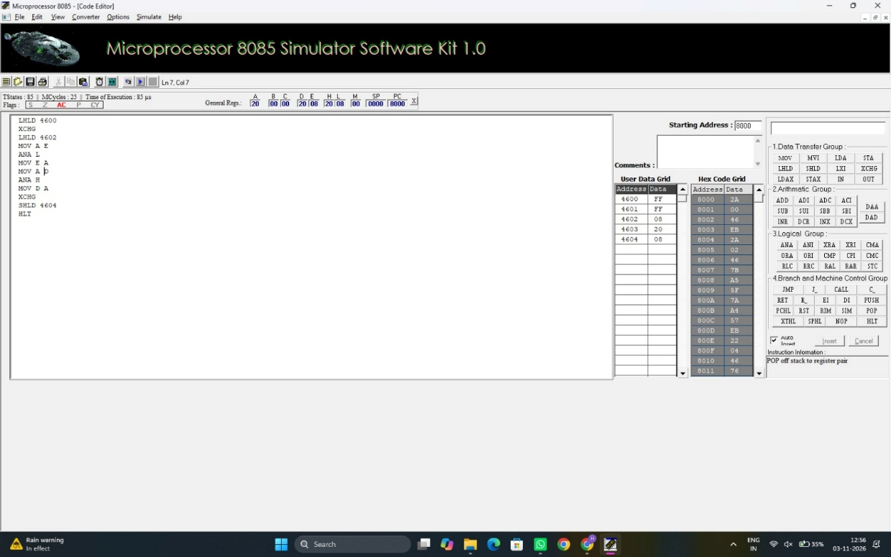

Data Table:
4600 | FF
4601 | FF
4602 | 08
4603 | 20
4604 | 08

Code:
BIT(16 bit):
LHLD 4600
XCHG
LHLD 4602
MOV A, E
ORA L
MOV E, A
MOV A, D
ORA H
MOV D, A
XCHG
SHLD 4604
HLT
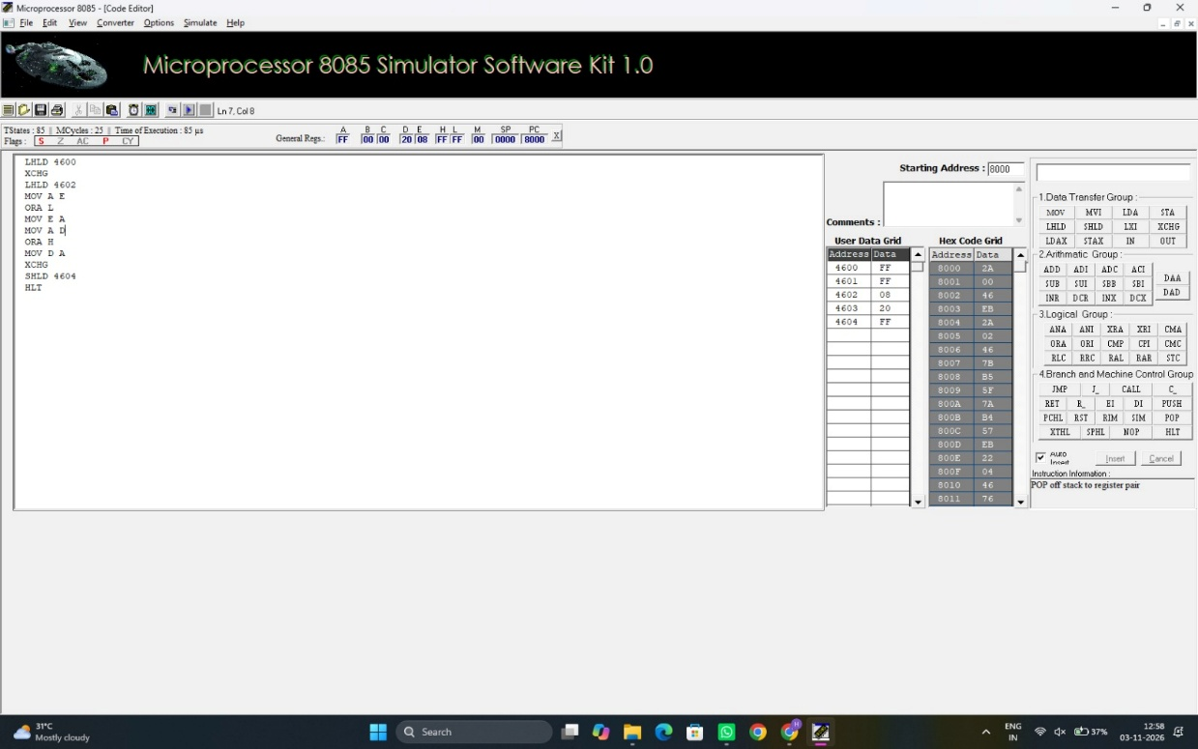
Data Table:
4600 | FF
4601 | FF
4602 | 08
4603 | 20
4604 | 08

  - To analyze and verify Shift and Rotation operations (Logical/Arithmetic shifts left and right) using 8-bit data.
Code:
Left Shift(8 bit):
LDA 4600
ADD A
STA 4601
HLT
Data Table:
4600 | 05
4601 | 0A
4602 | 00

Code:
Right Shift(8 bit):
XRA A
LDA 4600
RAR
STA 4601
HLT
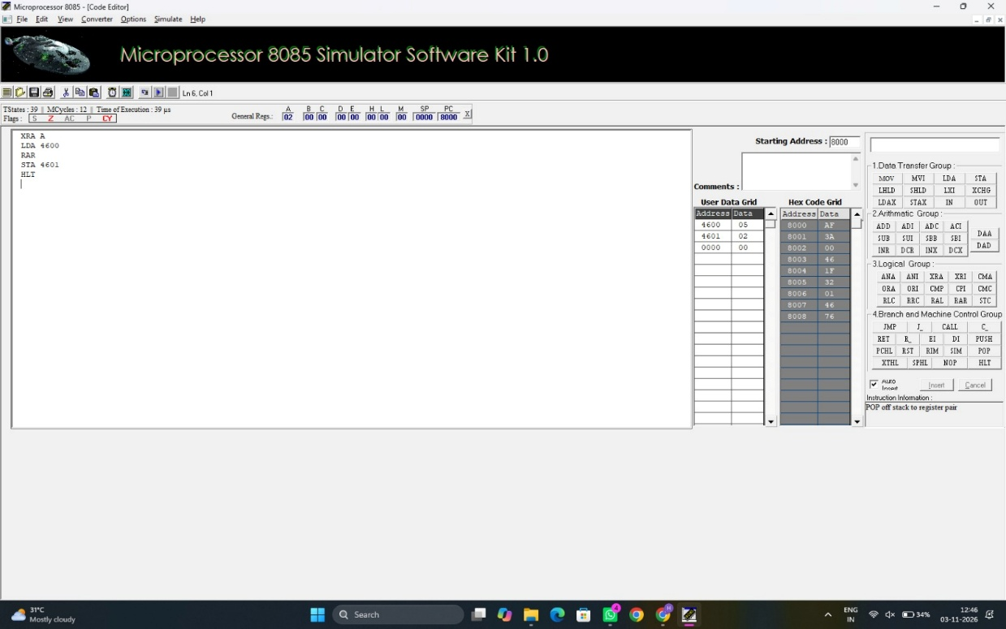
Data Table:
4600 | 05
4601 | 02
4602 | 00

Code:
Left Shift(16 bit):
LHLD 4600
DAD H
SHLD 4602
HLT
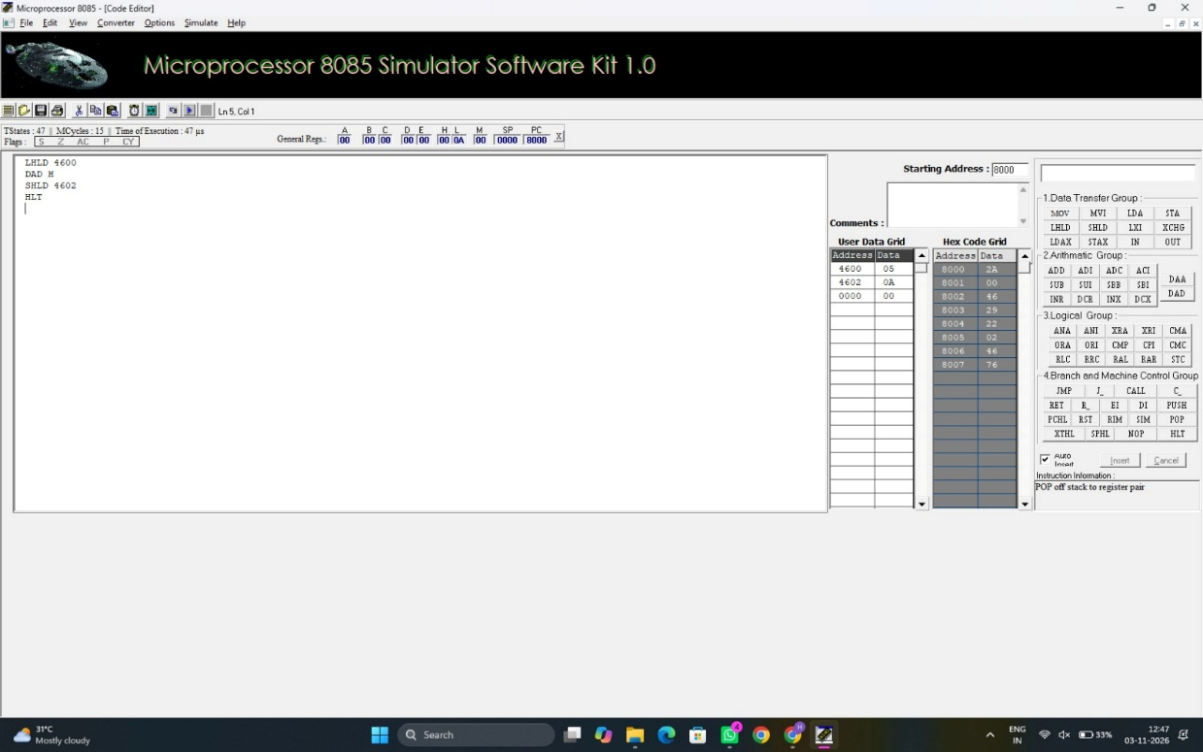
Data Table:
4600 | 05
4601 | 0A
4602 | 00

Code:
Right Shift(16 bit):
XRA A
LHLD 4600
MOV A, H
RAR
MOV H, A
MOV A, L
RAR
MOV L, A
SHLD 4602
HLT
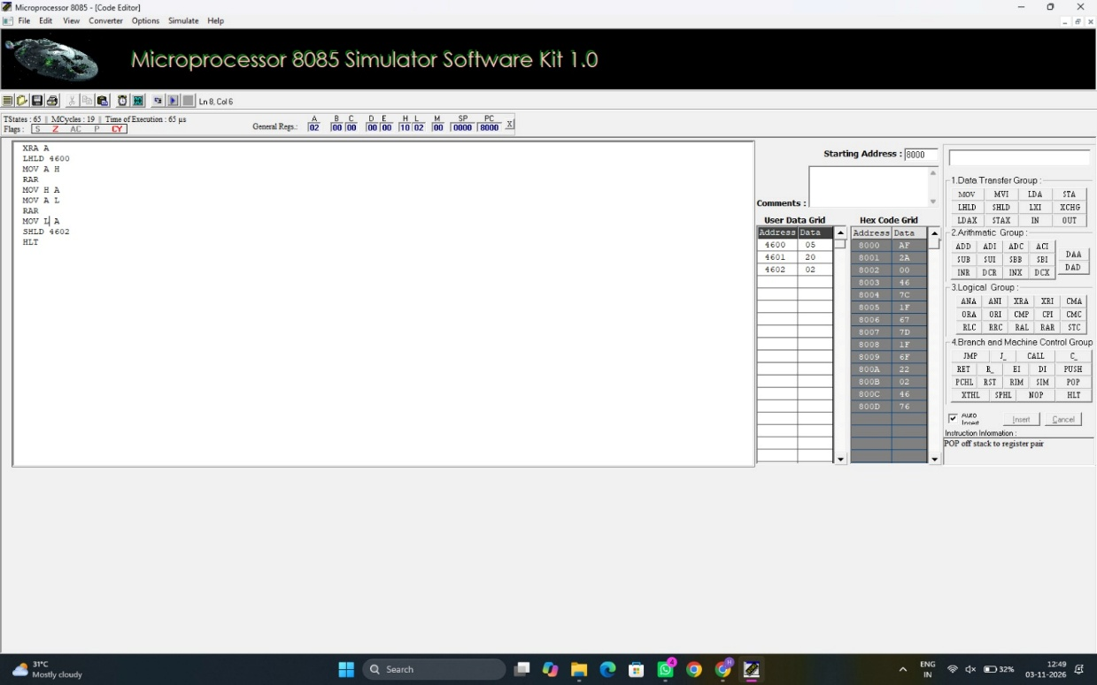
Data Table:
4600 | 05
4601 | 02
4602 | 00

Result:
1. 8-bit Addition and Subtraction: The target memory location holds the correct 8-bit sum or difference, and the adjacent byte records 01H if an overflow carry or borrow occurred, or 00H if it did not.
2. 16-bit Addition and Subtraction: The sequential memory addresses store the low and high bytes of the correct 16-bit sum or difference, along with a final byte reflecting the state of the terminal carry or borrow flag.
3. 8-bit Multiplication and Division: The output registers or memory addresses contain either a combined 16-bit product from repeated addition, or two distinct 8-bit bytes representing the exact Quotient and Remainder from repeated subtraction.
4. 16-bit Multiplication and Division: The designated target memory blocks accurately hold a multi-byte product (up to 32 bits) generated by the double-addition loop, or a pair of 16-bit values containing the final Quotient and Remainder

